Name:_______________
Date:__________________

Karyotype Lab

Arizona Science Standards:
- S4 –C2-PO1, 4

Ag Standards:
- 16.0 – Use Scientific processes to analyze data
- 17.2 – Examine the molecular basis of heredity and resulting genetic diversity

Objectives:
- Define karyotype
- Describe various genetic disorders based on number of chromosomes

Background:

When studying mitosis, you learned that humans have a diploid number of 46 chromosomes, in 23 matching pairs. This means that humans have 23 sets of chromosomes that code for all of our genetic traits. The actual way each trait is expressed depends on the competing expressions of each chromosome in a pair. One chromosome in each set comes from your mother and the other chromosome in each set comes from your father.
Meiosis does not always work perfectly, however. Sometimes a process called nondisjunction occurs. In nondisjunction, the chromosomes (either full or part) do not separate properly during anaphase I or anaphase II. This results in haploid daughter cells that have extra or missing chromosomes. If, by chance, the gamete created from this nondisjunction happens to mate, the offspring created can have an extra or missing chromosome, leading to genetic disorders.
Karyotyping is a scientific technique in which a picture is taken of the chromosomes of an offspring believed to have a genetic disorder. The random chromosomes, all jumbled up, are then matched with their partner and arranged in order from 1 to 23 (the sex chromosomes). Once all the chromosomes are matched up, any missing or extra chromosomes can be found and the exact genetic disorder can be determined.

Pre-Lab Questions:
- What is nondisjunction?

- What is karyotyping?

- How many chromosomes does an individual have?

Materials:
- Chromosome worksheet
- Scissors
- Glue or Tape

Procedure:
- Cut out each chromosomes
- Match them up with their homologous pair
- Arrange and glue them on the sheet from #1 through #23 (the sex chromosomes).
  - In order, the #1 chromosome is the longest and #22 is the shortest. Chromosomes 13 – 15 have centromeres that are near the ends – not in the middle!
  - If you have a male, the #23 chromosomes will not look alike. One will be labeled X and the other Y.
  - You have been given complete copies of normal males and normal females for comparison.
  - Use the dark/light banding patterns to help you match!
- Determine the genetic disorder that your offspring has.
  - What is the Genetic Disorder?
    - If the offspring has XXY – Kleinfelter's Syndrome
    - If the offspring has an extra #13 chromosome – Patau Syndrome
    - If the offspring has an extra #18 chromosome – Edward's Syndrome
    - If the offspring has an extra #21 chromosome – Down's Syndrome
    - If the offspring has a missing a sex chromosome (X only) – Turner's Syndrome

Data Collection:

1 2 3 4 5

6 7 8 9 10 11 12

13 14 15 16 17 18

19 20 21 22 X Y

Post Lab Questions:

What was the letter on your set type? _____________________

What is the genetic disorder? ______________________________________
If the offspring has XXY – Kleinfelter's Syndrome
If the offspring has an extra #13 chromosome – Patau Syndrome
If the offspring has an extra #18 chromosome – Edward's Syndrome
If the offspring has an extra #21 chromosome – Down's Syndrome
If the offspring has a missing a sex chromosome (X only) – Turner's Syndrome

Research some symptoms of your genetic disorder and list them below:
Normal Male Karyotype
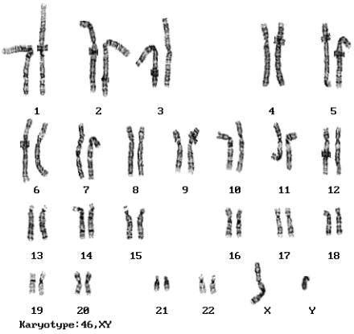

Normal Female Karyotype

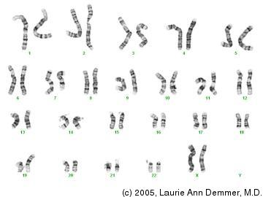

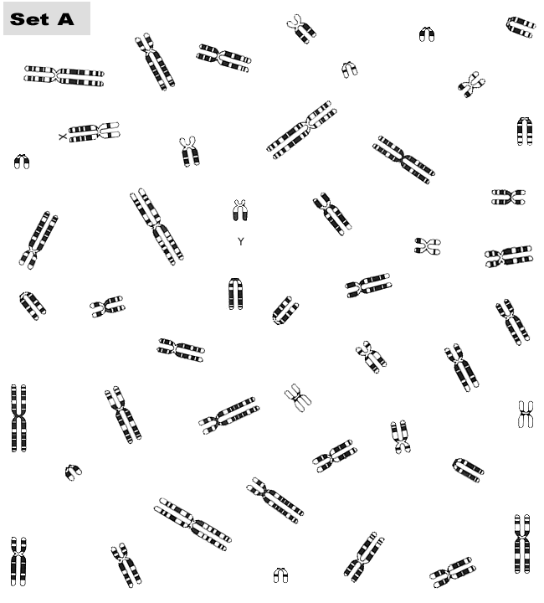

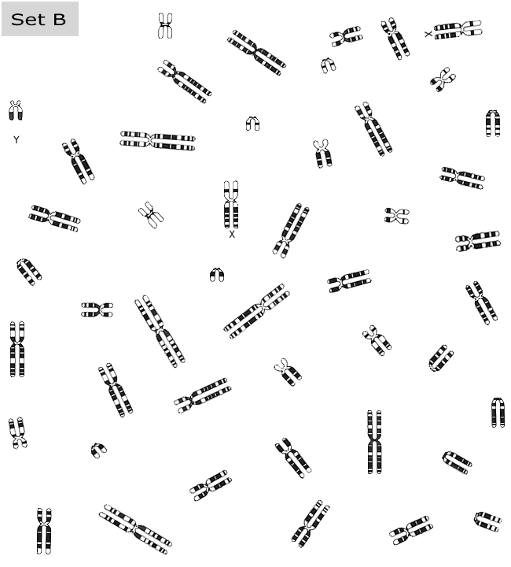

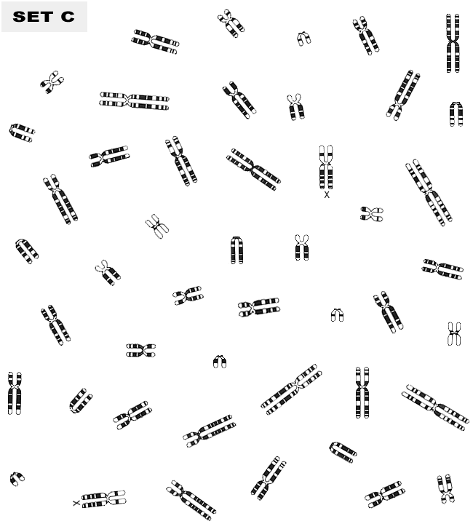

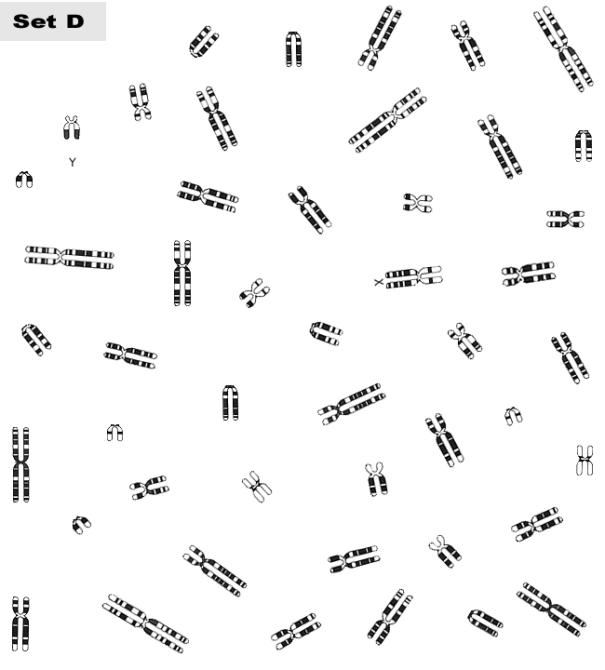

SET E

